Name:
Div:
Roll No:

DMBI Experiment 03

Aim: Experiment to preprocess a loan dataset using different preprocessing techniques.

Theory:
Introduction
Loan approval prediction is a critical task in the financial sector, helping banks and lending institutions assess the risk of granting loans to applicants. With the rise of digital banking, the volume of loan applications has increased significantly, making manual evaluation inefficient. Machine learning-based systems offer a powerful solution by analyzing applicant data to predict whether a loan should be approved or rejected. These systems rely on features such as income, credit history, and loan amount to make accurate predictions. However, the quality of the dataset directly impacts the performance of these models, necessitating robust data preprocessing.

This experiment focuses on preprocessing a loan dataset to ensure it is suitable for training a machine learning model for loan approval prediction. The study aligns with research in financial data mining, where preprocessing techniques like handling missing values, encoding categorical variables, and normalizing numerical features are essential for improving model accuracy.

Dataset Overview
The dataset used in this study is a loan approval dataset containing 600+ instances (as shown in the sample). It includes a mix of categorical and numerical attributes related to loan applicants. The target variable is `Loan_Status`, which indicates whether a loan was approved (Y) or not (N). Since data quality significantly impacts model performance, we apply comprehensive preprocessing techniques such as handling missing values, feature encoding, normalization, and outlier removal.

Input Variables (Features)
The dataset includes the following attributes, which serve as key indicators for predicting loan approval:
1. Gender - Male/Female (categorical).
2. Married - Yes/No (categorical).
3. Dependents - Number of dependents (categorical: 0, 1, 2, etc.).
4. Education - Graduate/Not Graduate (categorical).
5. Self_Employed - Yes/No (categorical).
6. ApplicantIncome - Income of the applicant (numerical).
7. CoapplicantIncome - Income of the co-applicant (numerical).
8. LoanAmount - Loan amount in thousands (numerical).
9. Loan_Amount_Term - Loan term in months (numerical).
10. Credit_History - 1 (good) or 0 (bad) (categorical).
11. Property_Area - Urban/Rural (categorical).

These attributes are selected for their relevance to loan approval decisions, allowing models to effectively differentiate between approved and rejected applications.

Target Variable (Output)
- Loan_Status (Y/N) - A binary label indicating whether a loan was approved (Y) or rejected (N).

Importance of Data Preprocessing
The effectiveness of loan approval prediction models relies on high-quality data. Raw datasets often contain missing values, noisy data, outliers, and irrelevant attributes, which can lead to biased or inaccurate predictions. To ensure the dataset is well-prepared for model training, we implement the following preprocessing techniques:

1. Data Cleaning:
- Handling missing values by removal or imputation (mean, median, mode).
- Removing noisy data using binning techniques and outlier detection (IQR & Boxplot analysis).

2. Data Transformation:
- Encoding categorical variables (One-Hot Encoding for nominal attributes).
- Normalization using Z-score transformation to standardize feature values.

3. Data Reduction:
- Attribute-oriented induction to remove redundant or less relevant data.

These preprocessing steps enhance model accuracy, reduce computational overhead, and improve feature interpretability, making loan approval prediction systems more efficient.

Dataset Image:
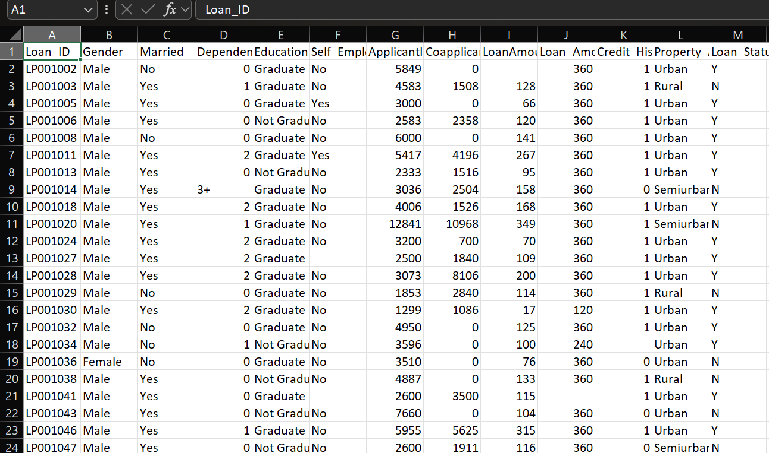

2. Handling Missing Values:

Objective:
To ensure the dataset is complete and does not have missing values that could negatively impact model performance.
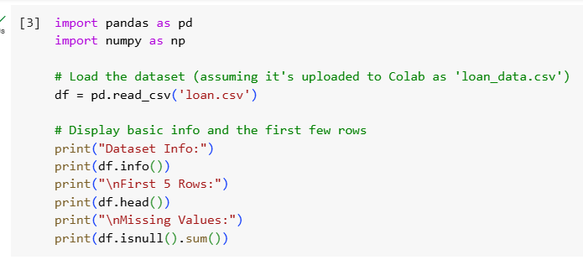
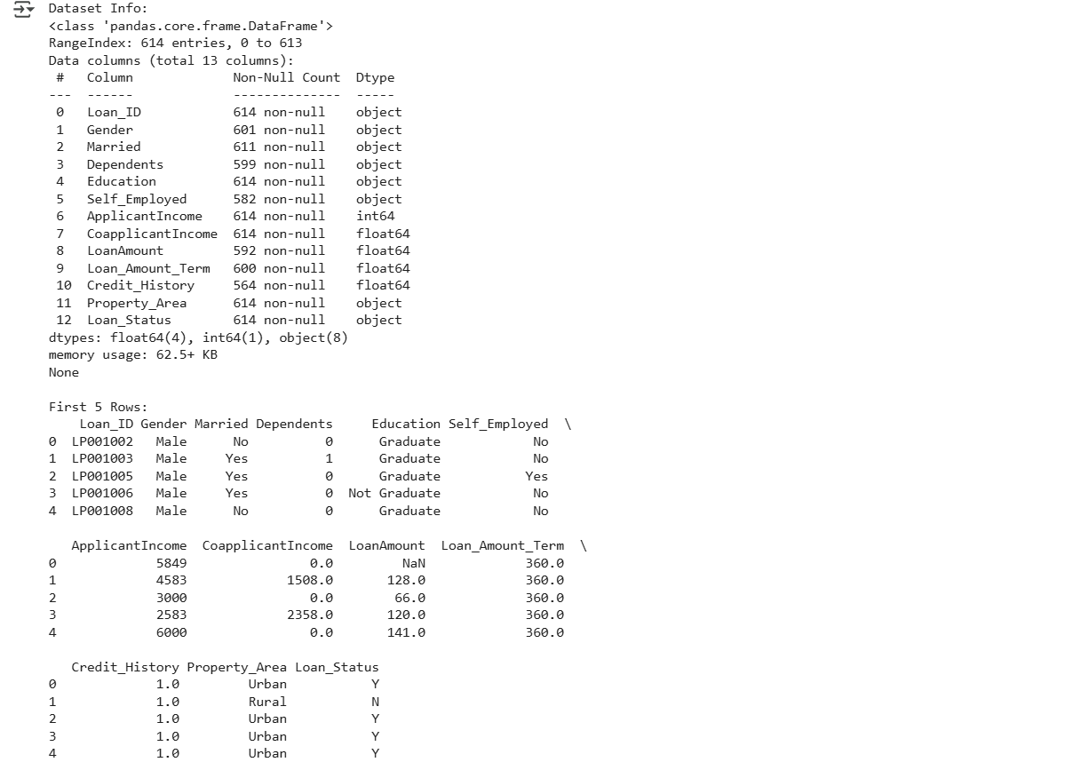
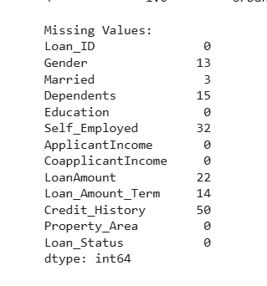
Steps Performed:
1. Threshold-Based Row Removal: Rows with more than 50% missing values were removed.
2. Mean Imputation: Remaining missing values in numerical columns (e.g., ApplicantIncome, CoapplicantIncome, LoanAmount) were replaced with the mean value of the respective column.
3. Mode Imputation: Missing values in categorical columns (e.g., Gender, Married, Credit_History) were replaced with the mode (most frequent value) of the respective column.

Impact:
- The dataset retained its integrity while avoiding unnecessary data loss.
- Imputation helped preserve the dataset’s structure and statistical properties.

3. Outlier Removal Using IQR:

Objective:
To remove extreme values that may skew the dataset and negatively affect model training.
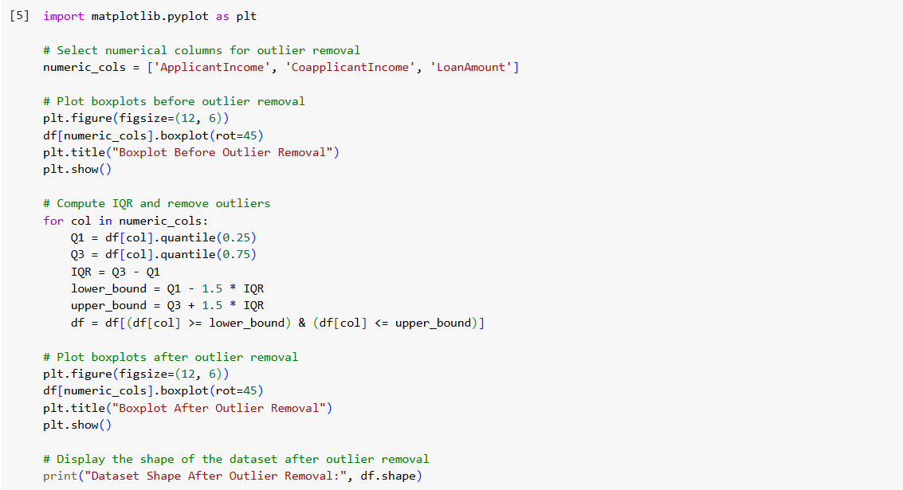
Steps Performed:
1. Boxplots were plotted to visually inspect outliers in numerical attributes (ApplicantIncome, CoapplicantIncome, LoanAmount).
2. Interquartile Range (IQR) was computed:
- Q1 (25th percentile) and Q3 (75th percentile) were identified.
- IQR = Q3 - Q1
- Data points below (Q1 - 1.5 * IQR) or above (Q3 + 1.5 * IQR) were removed.

4. Boxplots were re-plotted to confirm that extreme values were successfully removed.
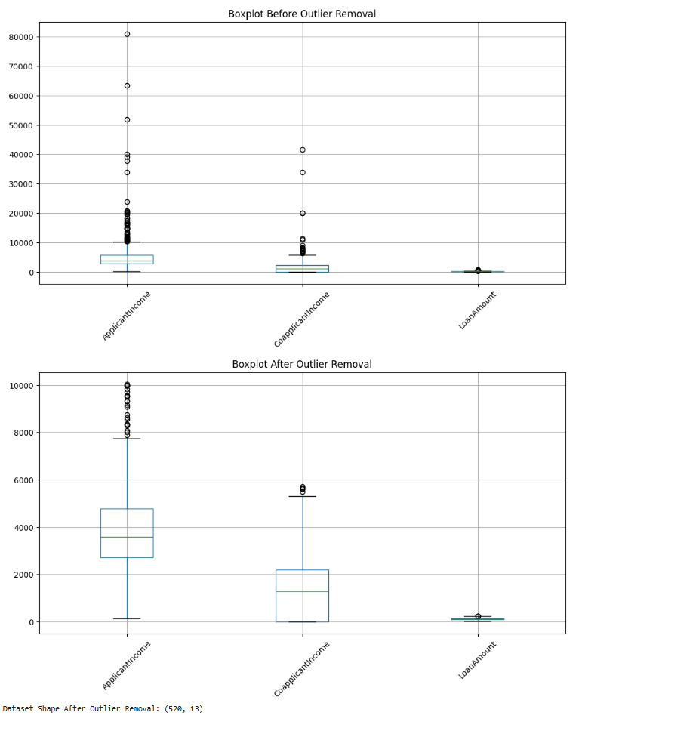
Impact:
- Outliers that could have biased the model’s learning process were removed.
- Improved model robustness by ensuring data distribution is well-structured.

Observation
- Before Outlier Removal:
  - ApplicantIncome: There are several outliers above 10,000, with some extreme values reaching up to 80,000.
  - CoapplicantIncome: Outliers are present above 5,000, with some values exceeding 40,000.
  - LoanAmount: A few outliers are visible above 300, with some reaching up to 600.
- After Outlier Removal:
  - ApplicantIncome: The outliers above 10,000 are reduced, but some values around 10,000 still remain as outliers. This suggests that the IQR method removed the most extreme values, but the distribution might still have a long tail.
  - CoapplicantIncome: Outliers above 5,000 are mostly removed, though a few remain around 6,000.
  - LoanAmount: Outliers above 300 are removed, and the range looks much tighter now.
Dataset Shape:
- Originally, the dataset had 614 rows (as seen in the initial exploration).
- After outlier removal, the dataset has 526 rows. This means 88 rows were removed due to outliers in ApplicantIncome, CoapplicantIncome, or LoanAmount.
Observation Summary: The outlier removal worked, as the boxplots show a reduction in extreme values. However, some outliers still remain, which is expected because we applied the IQR method sequentially for each column. Rows that were outliers in one column might have been removed, affecting the distribution in others. If you want to be more aggressive with outlier removal, we could adjust the IQR multiplier (e.g., from 1.5 to 1.0), but for now, this is a good start, and we’ll proceed as per Mohit’s flow.

4. Binning and Smoothing:

Objective:
To transform continuous numerical data into categorical bins, making it easier for the model to learn patterns.
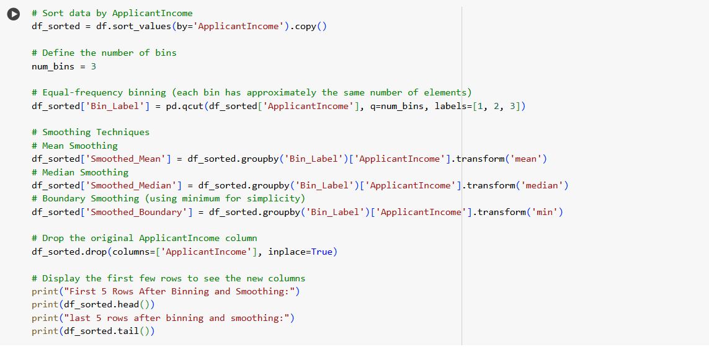
Steps Performed:
1. Sorting the Data by the ApplicantIncome attribute.
2. Equal-Frequency Binning:
- The ApplicantIncome attribute was divided into 3 equal-sized bins.
- Bins were labeled as 1, 2, and 3.
3. Smoothing Techniques Applied:
- Mean Smoothing: Each bin’s values were replaced with the bin’s mean.
- Median Smoothing: Values replaced with the median of the bin.
- Boundary Smoothing: Values replaced with the bin’s minimum or maximum value if they fell below or above respective thresholds.
4. Original Column Dropped: The ApplicantIncome column was removed after transformation.
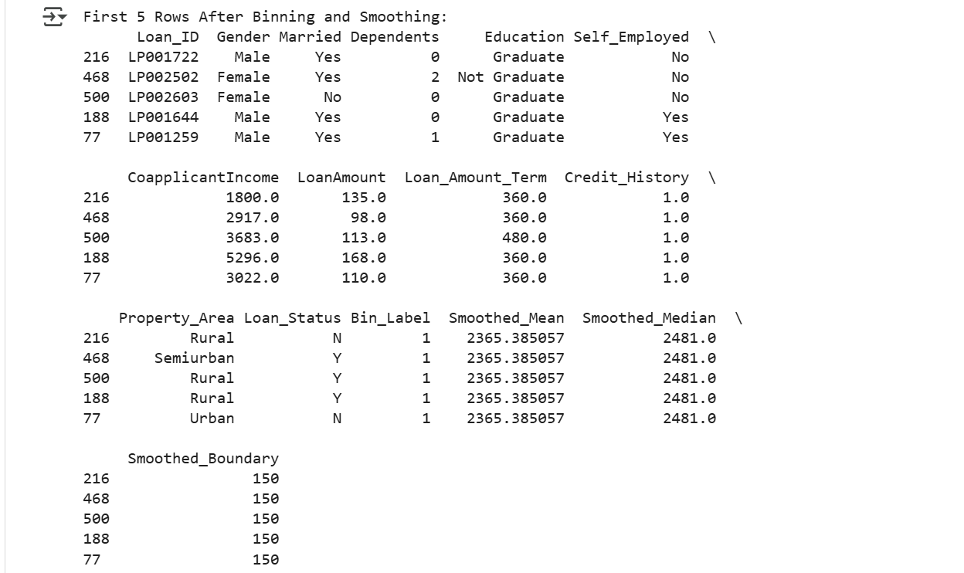
Impact:
- Reduced data noise and improved generalization of the model.
- Transformed a continuous variable into categorical bins, enhancing interpretability.

5. One-Hot Encoding & Normalization (Z-Score Standardization):

One-Hot Encoding:
Objective:
To convert categorical variables into numerical format for machine learning algorithms.
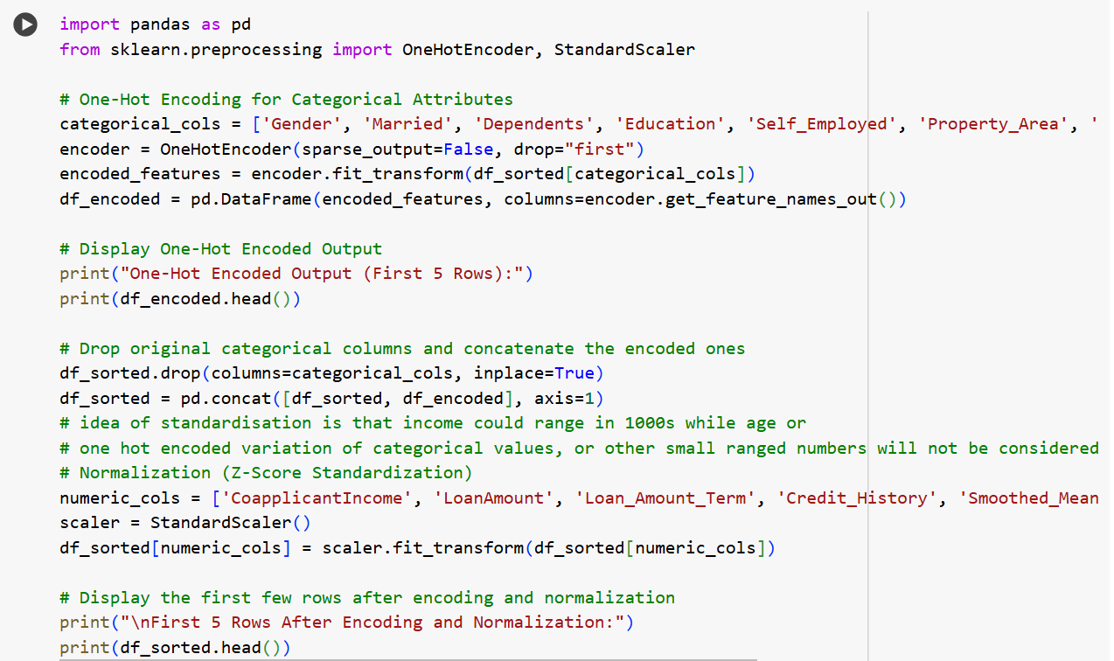
Steps Performed:
1. One-Hot Encoding was applied to categorical columns (Gender, Married, Education, Self_Employed, Property_Area) using OneHotEncoder.
2. New binary columns were created for each category, avoiding ordinal bias.
3. Original categorical columns were dropped after encoding.

Impact:
- Converted categorical data into a format suitable for machine learning models.
- Prevented bias that could arise from assigning numerical values to categories directly.

Normalization:
Objective:
To scale all numerical attributes to a standard normal distribution for better model convergence.

Steps Performed:
1. StandardScaler was applied to transform all numerical features (e.g., CoapplicantIncome, LoanAmount, Loan_Amount_Term):
- Mean of each feature was set to 0.
- Standard deviation set to 1.
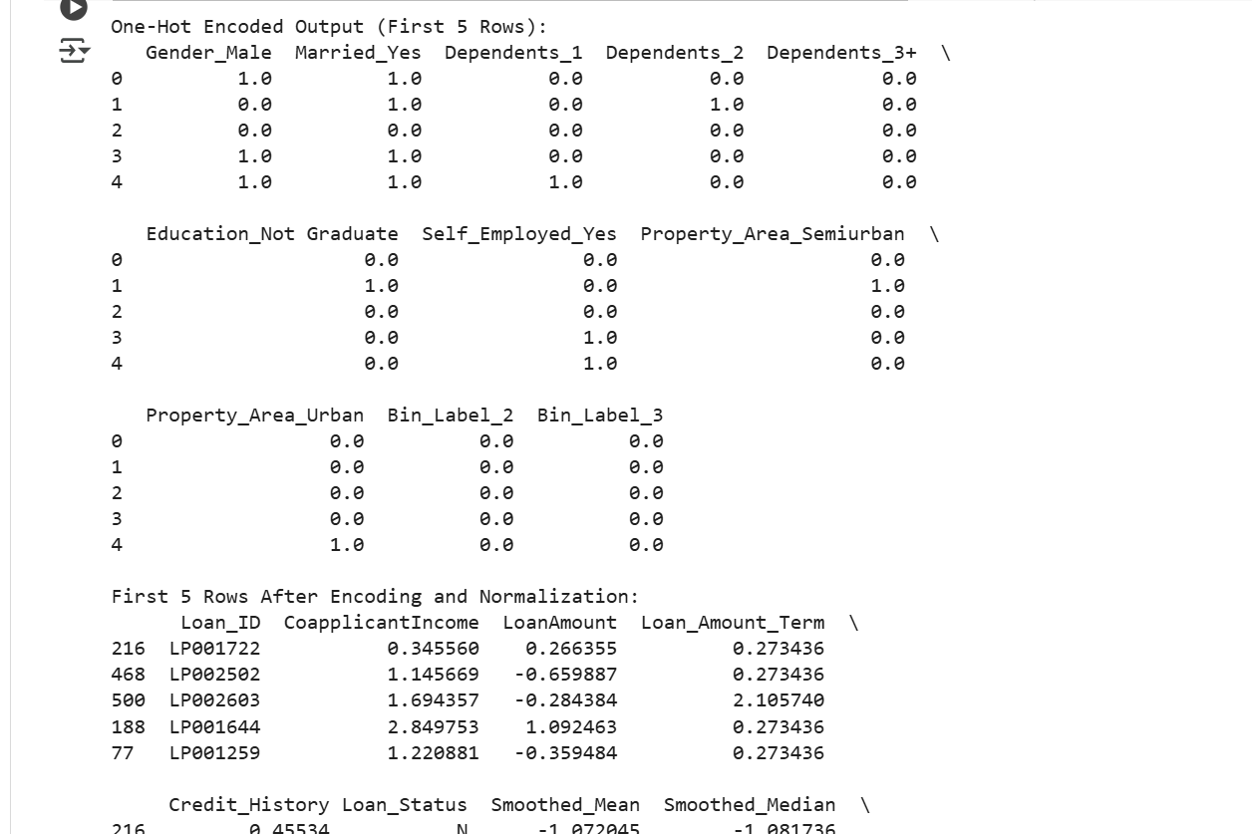
Impact:
- Ensured that all features contributed equally to model training.
- Improved the performance of machine learning algorithms that rely on distance-based metrics.

Observations : The encoding and normalization worked as expected. The categorical variables are now binary columns, and the numerical columns have been transformed into a standardized scale.

6. Data Reduction

Attribute-Oriented Induction
Objective:
To reduce dataset size by aggregating records while preserving essential characteristics.
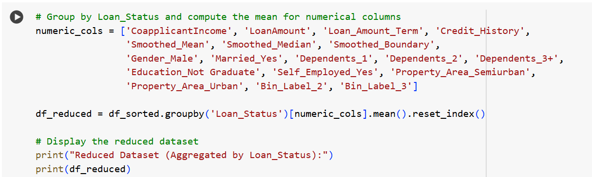
Steps Performed:
1. Records were grouped by the Loan_Status attribute.
2. Mean values were computed for each numerical feature within each loan status class (Y/N).
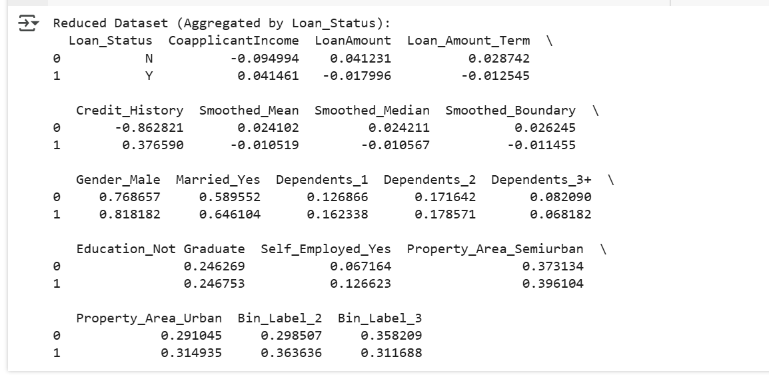
Impact:
- Reduced data size while retaining useful patterns for loan approval prediction.
- Allowed the dataset to be more manageable for further model training.
Observation: The reduced dataset captures the average characteristics of approved (Y) and not approved (N) loans. For example, approved loans tend to have better credit history, slightly more semiurban applicants, and a balanced income distribution. This reduced dataset can be useful for exploratory analysis or feature selection.

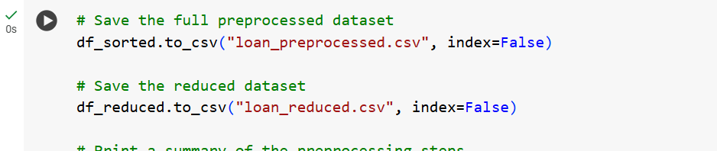

7. Results & Conclusion

Final Processed Datasets:
1. Full Preprocessed Dataset:
- File Name: loan_preprocessed.csv
- Contains the cleaned, transformed, and standardized data for machine learning.
2. Reduced Dataset:
- File Name: loan_reduced.csv
- Aggregated version, useful for exploratory data analysis and feature selection.

Overall Impact of Preprocessing:
- Improved Data Quality: Missing values were handled, outliers removed, and data was normalized.
- Enhanced Feature Engineering: Binning, smoothing, and encoding improved the dataset structure.
- Optimized Dataset for ML Models: Standardization ensured balanced learning, reducing bias.
- Better Computational Efficiency: Data reduction minimized storage needs while retaining insights.

By following this systematic approach, the dataset is now optimized for training machine learning models to accurately predict loan approvals and assist financial institutions in decision-making.

Preprocessed Dataset:
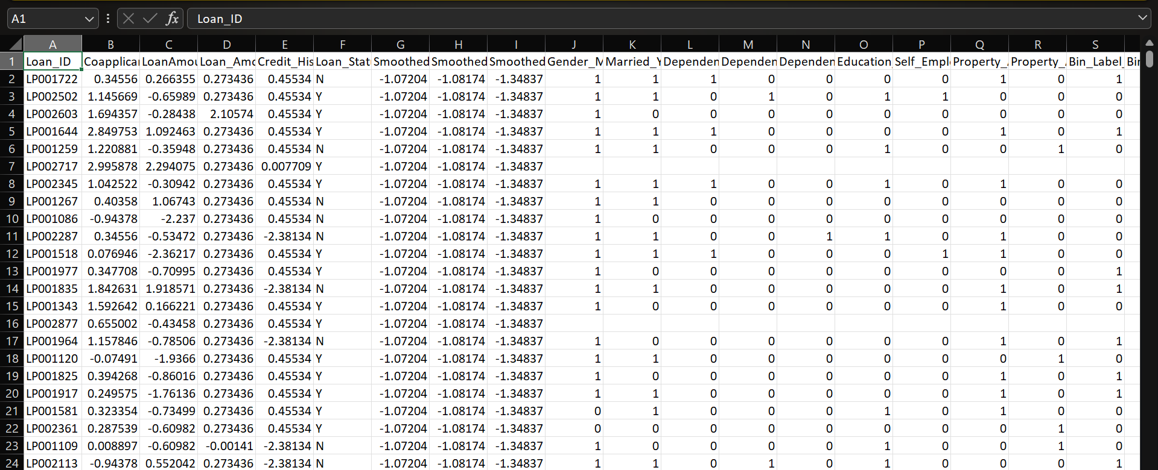

Reduced Dataset:
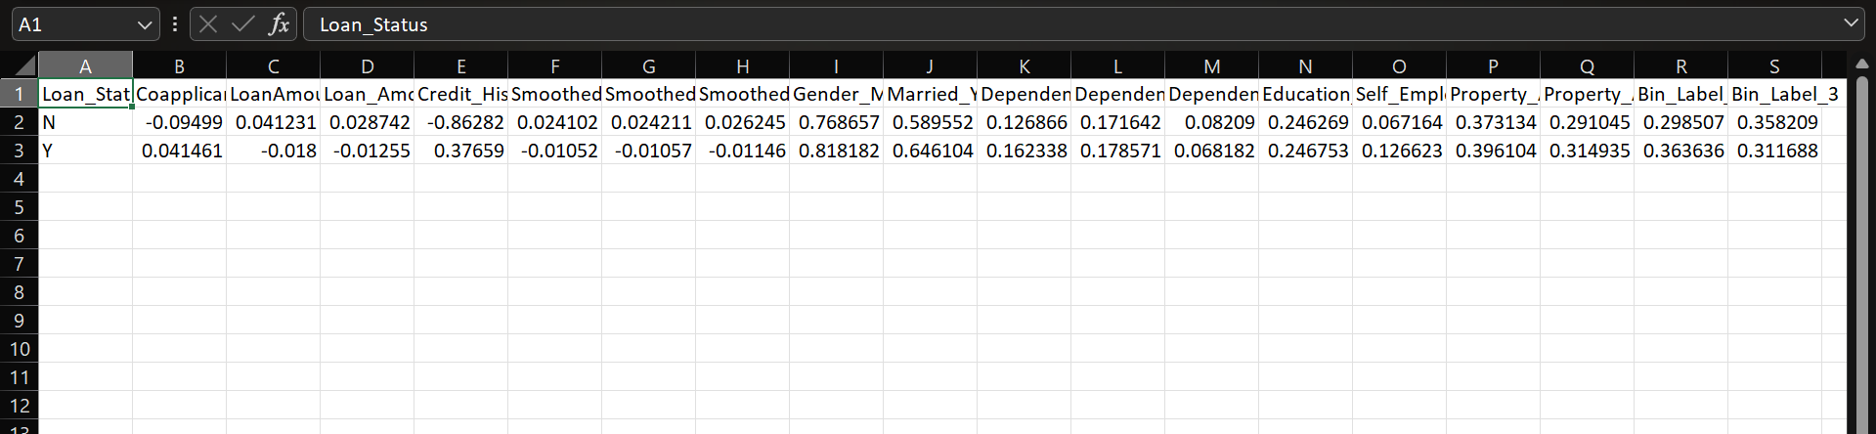

There are 4 main important steps for the preprocessing of data.
- Taking care of missing values
- Taking care of Categorical Features
- Normalization of data set
- Splitting of the data set in Training and Validation sets
Let us see execution of each step:

1)Taking care of missing values
Missing values can lead to incorrect model training and predictions. We handle them using methods like mean, median, mode, or dropping rows/columns.
Do read the comments in code execution for more clarity.
- df.isnull().sum(): Checks for missing values in each column.
- Loop through columns:
  - If categorical (object type), replace missing values with mode() (most frequent value).
  - If numerical, replace missing values with median() (better than mean for handling outliers).
- inplace=True: Modifies the DataFrame directly.
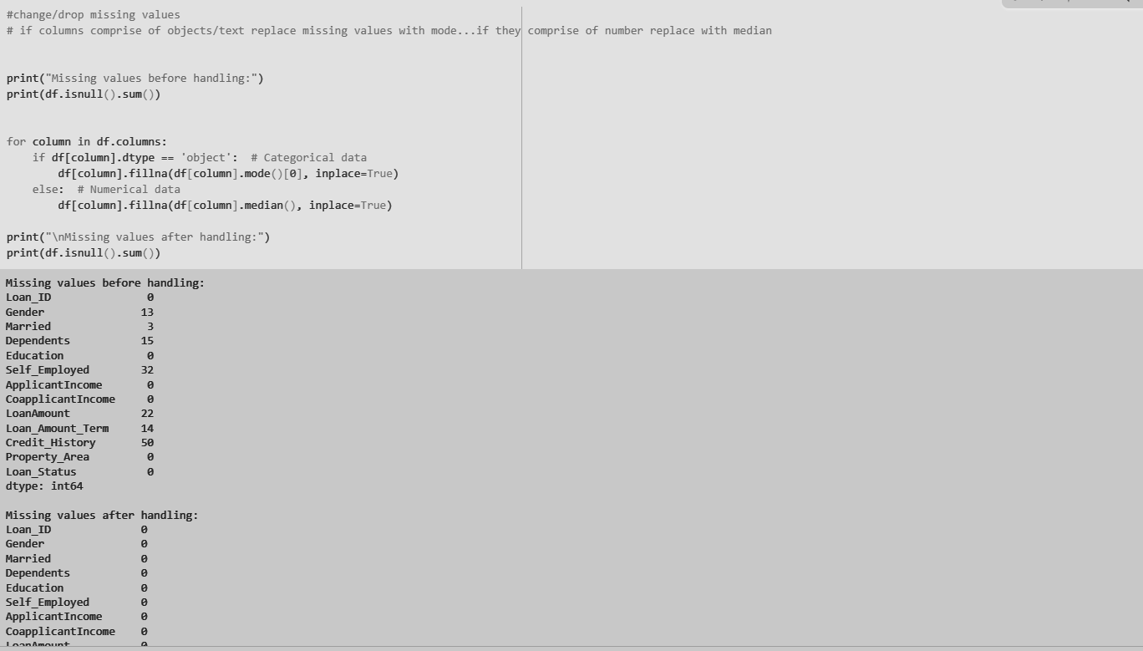
2) Taking care of Categorical Features
Machine learning models cannot work with categorical data directly. We must convert them into numerical format using Label Encoding.
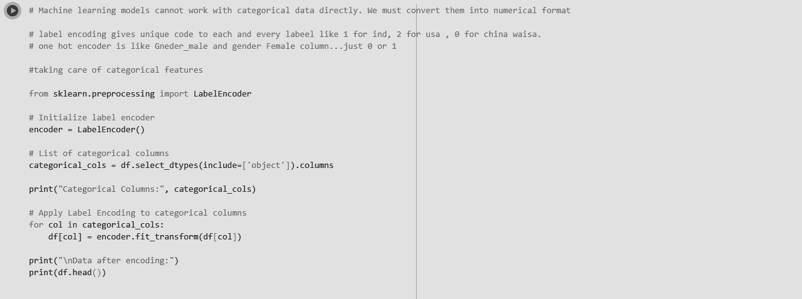
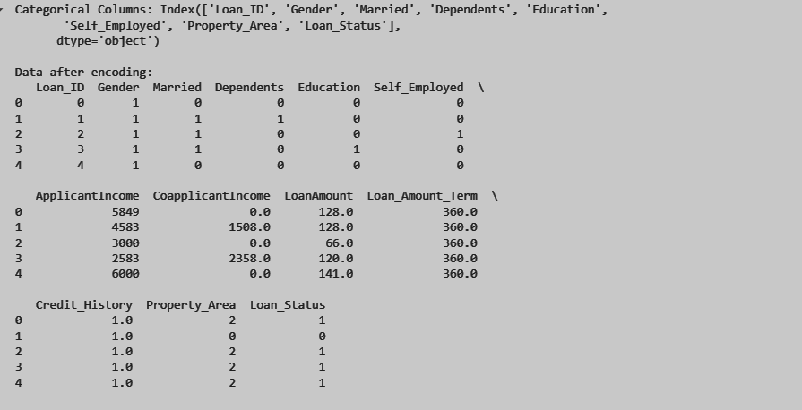

3) Normalization of the dataset
Different numerical columns have different scales, which can lead to biased models. Normalization scales values between 0 and 1 for better model performance.
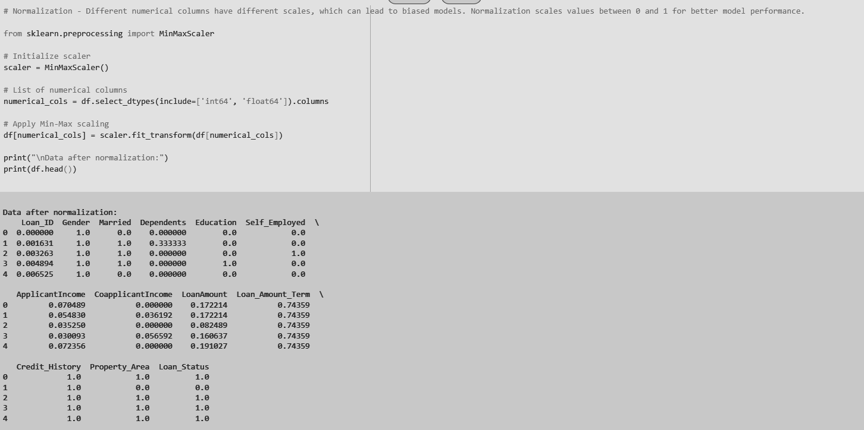
MinMaxScaler: Scales values between 0 and 1 using:
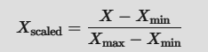
df.select_dtypes(include=['int64', 'float64']): Selects numerical columns.
scaler.fit_transform(df[numerical_cols]): Applies normalization.

4)Splitting of the data set in Training and Validation sets
To evaluate the model's performance, we split data into:
- Training Set (80%): Used for model training.
- Validation Set (20%): Used for testing.
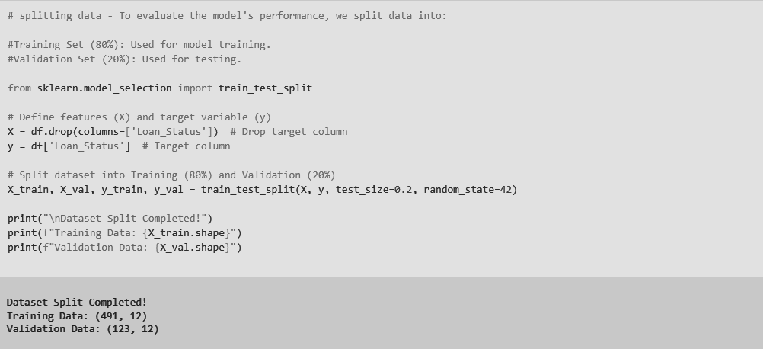
- Define Features (X) & Target (y):
  - df.drop(columns=['Loan_Status']): Drops target column (features).
  - df['Loan_Status']: Defines target variable.
- Split dataset:
  - train_test_split(X, y, test_size=0.2, random_state=42)
  - test_size=0.2: 20% data for validation.
  - random_state=42: Ensures consistent split every time.
Conclusion: Thus we have successfully performed Preprocessing operation on our dataset.

